Published in Active Learning Spaces: New Directions for Teaching and Learning, Number 137, March 2014, San Francisco: Jossey-Bass. <http://www.wiley.com/WileyCDA/WileyTitle/productCd-1118870115,subjectCd-EDZ0.html>
This chapter examines active learning spaces as they have developed over the years. We will see consistently well-designed classrooms can facilitate active learning even though the details of implementing pedagogies may differ.

History and Evolution of Active Learning Spaces
Robert J. Beichner

The value and efficacy of active learning is discussed in detail elsewhere in this volume. In this chapter we focus our attention on the origins of classrooms designed to facilitate active learning.

Why should learning spaces change?
Before we describe the commonalities and differences of active learning environments, we should first consider why we would want to make these modifications from our “tried and true” classrooms in the first place. Some of the classroom adaptations can be quite expensive, so we should have a good reason to go down this path of educational reform.

The world is different.
Our species has changed from hunter-gatherers to fast-food fanatics. In fact, the current overabundance of food has resulted in serious health problems as our bodies continue to seek calorie-rich satiation. This would have been absolutely unthinkable a dozen generations ago, just yesterday in our evolutionary history. In an analogous manner, we've gone from carefully copied manuscripts owned by an elite few to online blogs published by teenagers. Our legal system and ideas of morality have yet to catch up, as copyright laws are ignored and "sexting" is practiced by a sizable fraction of our youth. Today’s students are used to and expect continuous connection to information and people. Forcing them to put their personal technology away during class contradicts the way they live their lives and gives students one more reason to expect that what they learn in school will have little relationship to reality.

Information is readily accessible.
A Google search on the word "google" results in 12 billion hits in less than 1/100th of a second. Additionally, the list of relevant websites it produces is not in random, alphabetical, or even chronological order. Google's amazing search algorithms somehow sort the results so well that if you can't find what you are looking for on the first or second page of hits, you probably need to tweak your search terms. The advent of tablets and smartphones has put the world's published information literally at our fingertips. Today's students have grown up with ubiquitous access to a storehouse more vast than the Library of Congress, and it's much more densely indexed! Shouldn’t that change what happens in schools?

Students are different.
Today’s college students probably learned to read by using Google, so they are very familiar with technology and have grown accustomed to and expect the instantaneous feedback. This affects student attitudes toward academic authority. Why should a student think of their professor as their only source of knowledge when their phone, in a fraction of a second, can find content that is more up to date than today’s lecture? And what if the instructor is trying to promulgate some suspect scheme like evolution? A quick search of the web produces scores of beautifully designed sites that convincingly explain that evolution is “just a theory.” Faculty no longer hold the monopoly on sources of information.
Technology has literally changed the way students think. People are often better at remembering how to find information than recalling the information itself. In a very real sense, our cognition is evolving. Evolution is the changing of some aspect of an organism because of a change in its environment. In this case, information is everywhere so we don't need to remember all the facts, just how to locate them. It only makes sense that our brains, a part of the body that was designed to very rapidly modify itself in response to internal or external stimulus (which is all that learning is), would display this type of evolutionary change.
Nowadays, people use technology from a very young age. 75% of children under age four use computers. The typical 8-18 year old spends seven and a half hours per day watching a screen, viewing nearly 11 hours of content. They average an outgoing text message every five minutes. We used to worry that watching too much TV would shorten kids' attention spans. That has probably happened, but today's technology has caused students to expect instant feedback and gratification when seeking something, be it information or contact with a friend. Although they might be willing to sit quietly and watch a movie (probably on a personal device rather than a television or cinema screen), it is more likely that they will also have a chat screen open as well as Facebook or Twitter. When they see a familiar actress, they might use IMDB to find out what other films she has made. They repeatedly reach out and fetch anything that is of interest to them at that moment. The world of information revolves around them. This has made it harder for students to learn from the kind of patient, orderly presentation that their teachers prefer. We have to do something different to reach them. We need to change classrooms so that students don't have to just sit passively, but can actively participate in their learning.

So why are lecture halls so common?
There is an easy answer to why we’ve kept using lecture halls for so many years…they worked for us! But we in academia are quite unlike most of our students.
Formal classrooms have a long history. There were instructional spaces in ancient Samaria that were clearly teacher-centric. To uncover the history of lecture halls we have to take a sidetrack. One of the earliest large-scale spaces where many people watched an individual or small band of performers was the Theatre of Dionysus in Athens. It dates from about 500 BCE. Dionysus was the Greek god of wine and the space was used for religious services. It was also an entertainment venue for the plays that were popular 2500 years ago. Our word "theatre" comes from the Greek word for the "beholding area" where patrons would sit to view the spectacle. A few generations later the Romans had similar uses for their spaces, which they called "auditoria" and filled with the "audience." Evidently instead of “beholding” like the Greeks, the Romans were listening to the audio aspects of the events being presented! All was good and these spaces served their intended purposes very well.
About 1000 years later, Pope Gregory VII decided the clergy needed to be educated. This was a good idea since clerics were very powerful and it was important that they all were properly trained in Church dogma. As far as I can ascertain, this was the first time in history that a large number of people needed to be educated at once. Up until then, teachers worked with their small, loyal band of disciples. Now the economics of scale required a new approach and the Pope came up with a brilliant solution. The clergy often lived in monasteries that had auditoria for their religious services. Many of these monks were unbelievably good at copying things down. People would spend their entire adult lives copying scriptures with incredible accuracy. Gregory’s clever idea was to use the existing technology to capitalize on and extend people's skills. The auditoria were filled with monks sitting in what now became lecture halls, copying down the words read by the "lecturer" (from the Latin for "reader") as they progressed through their manuscript. Lecturers could actually be fined if they deviated from what was written in front of them. When finished, each clergyman had their very own faithfully copied manuscript and they could hire themselves out as a lecturer somewhere else. Considering that the Pope's decree came down in 1079, nearly 400 years before Gutenberg's printing press, this was a fantastic way to accurately duplicate and disseminate materials. In fact, it was such a great combination of ideas that we've been continuing to do it for more than 10 centuries.
Change arrives slowly
Lecturing is really a logical continuation of very ancient oral traditions of religious and cultural education, which sprang from times when reading and writing skills were very rare or even non-existent. As more and more people sought education, an industry arose to meet society’s needs. Early universities in Bologna, Paris, and elsewhere perpetuated the lecture model, even after the advent of the printing press. Requiring students to attend lectures, when they could have independently read the material in one of the rapidly growing number of books, allowed teachers to maintain their historical authoritative role.
Active learning in labs
For the most part, this was the story until we finally reach modern times. By then, teachers had noticed that their students were not learning as much as they should from the lecture approach. European chemists like Friedrich Stromyer and Johann von Fuchs began supplementing their lectures with laboratory work in the early 1800s. The first American to do this (in engineering) is believed to be Amos Eaton, who co-founded the Rensselaer Institute of Technology in 1824. In 1906 Robert Millikan, the physicist most well-known for finding the charge on a single electron, wrote a popular lab manual where he advocated the importance of hands-on experience to help students learn difficult concepts. He suggested what has since become a standard approach, which is to supplement three hours of lecture per week with two hour for laboratory. So teachers, at least in the sciences, were beginning to relinquish the position of the lecture as the sole means of instruction and incorporate active learning as part of their students’ education.
By the 1980s nearly all science programs were aware of anecdotal evidence that students benefitted from hands-on activities and so most offered lecture/lab combination courses. The idea of learning from interesting tasks had also spread to other content areas like foreign languages. Of course, performance-based classes in areas like music and the arts had existed for millennia. No one expected to learn how to play an oboe by just listening to someone tell them how to do it. Also during this time medical schools, starting with McMasters University, began trying what is now called problem-based learning or PBL. Students practiced hypothetical-deductive reasoning by solving complex, often real, medical cases. This approach, now accepted as standard practice for medical education, has since been applied to instruction across all scientific areas, although not as widely.
During the 1990s a growing body of rigorous research on learning began providing irrefutable data illustrating that students in lecture settings simply did not learn as much as their teachers hoped. The famous Force Concept Inventory in physics led the way, with Richard Hake and others supplying embarrassingly consistent indicators of students’ poor grasp of conceptual knowledge when they were taught in passive lecture settings. Perhaps recognizing the futility of trying to change lecture-based instruction, or maybe realizing that greater gains could be made by improving laboratory experiences, a large group of creative people began building and testing new instructional technologies for the lab. Ron Thornton and David Sokoloff designed a series of sensors and accompanying software for what came to be called Microcomputer-Based Labs or MBLs. These became extremely popular and essentially revolutionized what could be done in a laboratory setting. This required institutions to provide space and electrical power for computers, eventually setting up network connections as well. Many studies showed that MBLs, and their offspring, Video-Based Labs, helped students learn considerably more than when sitting and listening to straight lecturing.
Active learning in lectures
Faculty were still enamored with the lecture method, so people found ways to incorporate the newly developed technology into their classes, essentially making it less likely that students would simply sit and passively listen. Probably the most sophisticated approach is the Interactive Lecture Demo (ILD) which has students in a lecture hall or classroom (but not a lab) watch a demonstration and then predict the kind of data that would soon be gathered from teacher-operated computer sensors. Studies have shown considerable learning gains when instructors carefully follow the detailed ILD instructions.
One of the most popular uses of technology in lecture halls is the student response system or “clickers.” (These have actually been around for quite some time. Cornell’s Raphael Littauer used wired systems to collect student responses in the early 1970s.) This approach was greatly popularized by Eric Mazur at Harvard, who developed a technique he called Peer Instruction. Students are asked a carefully crafted question designed to elicit misunderstandings. They think for a minute and press a button on a remote control-like device to indicate their answer. The instructor displays a bar chart of the results, which often indicate a substantial difference of opinion across the class. Students are then encouraged to talk to their peers for a minute or two and re-vote. The updated bar chart shows that usually the logic of the correct answer wins the debate. This type of instruction promotes very active discussion, even in large lecture halls. In addition to this obvious advantage, it also provides the instructor with immediate and often surprising feedback on how misunderstandings can persist even after students listen to their carefully crafted lectures.
Trying to couple lectures and laboratories is an important means of improving the educational experience of students. However, it can be difficult to keep the two types of class synchronized, especially if there are multiple sections of each. Students with lab scheduled on Mondays may not have seen the material before, so their hands-on activity requires a sort of “discovery” of the principles, based on observations. In other words, they would be applying inductive reasoning. Peers who don’t take lab until later in the week might have already been exposed to the concepts in a Wednesday lecture. Their lab now becomes an exercise in verification and deductive reasoning. These two approaches are very different. Nonetheless, lecture/lab combinations, in the format suggested by Millikan in 1906, are still the norm.
History of studios
Over the past two decades efforts have been made to combine lecture classes and lab experiences into a single learning experience. Original work along these lines has been done in several places and now the “studio approach” is spreading rapidly across hundreds of institutions.
Of course, studios are not new. They stem from medieval apprenticeships, where students worked closely with the master to actively learn some craft or art. Eventually this sort of approach found its way into places like the Ecole des Beaux Arts in Paris, where students were judged based on the quality of their architectural design projects. The Bauhaus School in Germany was well known for its practical instruction in architecture, with students even working on construction sites.
Although starting in the arts and architecture, active learning eventually found its way into the general curriculum. The Quincy School System in Massachusetts had elementary students experiencing “constant activity” in the late 1800s, in what was called a “New Departure” from American education. Around the same time, John Dewey’s Laboratory School in Chicago incorporated collaborative learning into learning studios for older students, as shown in Figure 1. A few years later the Horace Mann High School in Gary, Indiana followed up on Dewey’s ideas and had students presenting to each other and critiquing everyone’s work.
---- Insert Figure 1 about here -------
Active learning in studios
A fairly recent advance is the use of studios for science, technology, math, and engineering (STEM) courses, where they make it easy to move back and forth between teacher presentation and student experimentation or other activity. This eliminates the synchronization problem of separate lecture and lab sections and replaces much of the less effective lecture time with active learning.
Pricilla Laws and colleagues created Workshop Physics in the late 1980s and early 1990s at Dickinson College. She made full use of MBL and VBL technologies and was able to replace lectures entirely with activities. Many of the experiments done by Workshop students promote kinesthetic learning, as can be seen in Figure 2. Before long the approach spread to other content areas like chemistry and biology. The influence of the Workshop Physics approach can be seen in all of today’s science studios.
One of the first (and few) places to adopt the studio approach on a school-wide basis was Rensselaer Polytechnic Institute. In the 1990s, under the leadership of Provost Jack Wilson, RPI converted many of their classrooms to studio designs like those in Figure 3. An assortment of high tech tools helped students as they worked. However, research found that implementing a studio space alone was not sufficient to ensure improvements in learning. This renovated classroom needed to be accompanied by research-based pedagogical techniques before significant gains on nationally normed tests were seen.
------- Insert Figure 2 and Figure 3 about here ------
The first attempt to bring the benefits of collaborative, studio-based learning to larger classes was the SCALE-UP (Student Centered Activities for Large Enrollment University Physics) project at North Carolina State University in the mid 1990s. Figure 4 shows the typical set of round tables whose purpose is to facilitate interactions between students and with the roaming instructor. Earlier research by a team led by Alexander Astin found that the quality of relationships students have with others is highly correlated with their academic success. The SCALE-UP table design was specifically selected to enhance social networking. Whiteboards surround the room as public thinking spaces and supplement smaller, group-sized boards. Teams of three students work on interesting problems, take measurements or make observations, or write computer models of physical phenomena. Research has documented a wide variety of advantages, including a five-fold reduction in failure rates for female students. The approach has since spread so that its use is no longer confined to just physics courses, or even large classes. All STEM areas as well as art, language, humanities, literature, etc. have been taught using this approach. Class sizes at more than 200 adopting institutions range from 24 to 200. Because of SCALE-UP’s expansion, project director Robert Beichner changed the acronym to mean Student Centered Active Learning Environment with Upside-down Pedagogies. The name now includes both the redesigned instructional space as well as the reformed pedagogy used inside.
------ Insert Figure 4 about here -----
Future of active learning classrooms
Classrooms that make it easier for students to actively participate in their learning are becoming more and more common. Spaces that are formally associated with just the SCALE-UP approach can be found at more than 200 institutions. Although this particular room design originally featured round tables, smaller SCALE-UP classrooms often have students seated at smaller “D”-shaped tables located around the periphery of the studio. Thus, they end up looking very much like the Workshop Physics arrangements first created at Dickinson College. This is no coincidence. Successful active learning classrooms, regardless of how many students are in the space, are designed to facilitate interactions between students as they work collaboratively on interesting tasks. Spaces and the furnishings within them are carefully designed with features that enable students to meet the goals of instruction. These goals vary from course to course and institution, but they increasingly include 21st century skills like problem solving, communication and teamsmanship. Active learning classrooms make it easy for faculty to assign tasks that require students to practice these skills as a means of learning the subject matter.
Evidence pointing out the efficacy of active learning continues to accumulate. At the same time, colleges and universities are feeling competitive pressure from on-line institutions and freely available course materials distributed via the web. The “flipped classroom,” where most course content is delivered outside of a formal learning space, is gaining in popularity. These outside influences are leading faculty to ask themselves how they can best use the valuable but limited time they have in the classroom with their students. Because active learning spaces and the research-based pedagogies they enable provide a readily available and well-tested answer, they will have a growing impact on the instructional scene.

Robert J. Beichner is an Alumni Distinguished Undergraduate Professor of Physics at North Carolina State University. He directs the NCST STEM (Science, Technology, Engineering, and Math) Education Initiative.

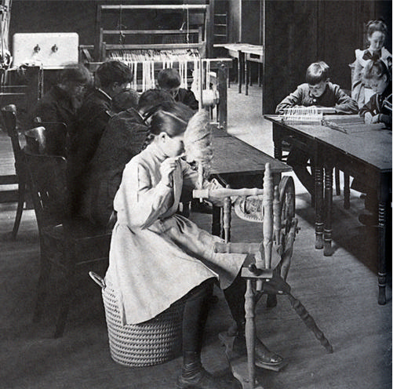

Figure 1. At Dewey’s Laboratory School students learned about textiles by actually spinning yarn. Social skills were developed by working together, as seen in the background. From “100 Years of Learning at The University of Chicago Laboratory Schools” by William Harms and Ida DePencier, 1996. Accessed on April 8, 2013 from http://www.ucls.uchicago.edu/data/files/gallery/HistoryBookDownloadsGallery/chapter1_3.pdf

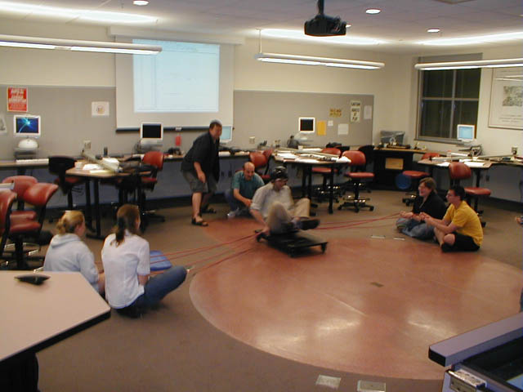

Figure 2. A Workshop Physics classroom at Dickinson College features custom-designed student tables surrounding a central area for large scale experiments. Accessed April 8, 2013 from http://physics.dickinson.edu/~wp_web/wp_lab&equip/wp_LabDesign.html.

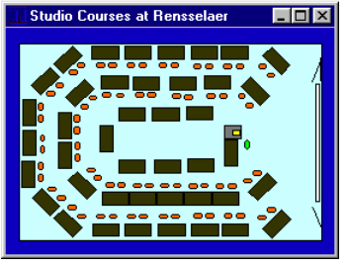

Figure 3. Classroom layout for studio courses at RPI. Students face outward, working on computers and taking data. The centrally located instructor can see all student screens. Students can turn to face the instructor when not working on activities. From “Studio Teaching: When the Future Becomes the Present,” by Jack M. Wilson, 1997, appearing in UniServe Science News, Volume 7, July 1997. Accessed on April 8, 2013 from http://science.uniserve.edu.au/newsletter/vol7/wilson.html.

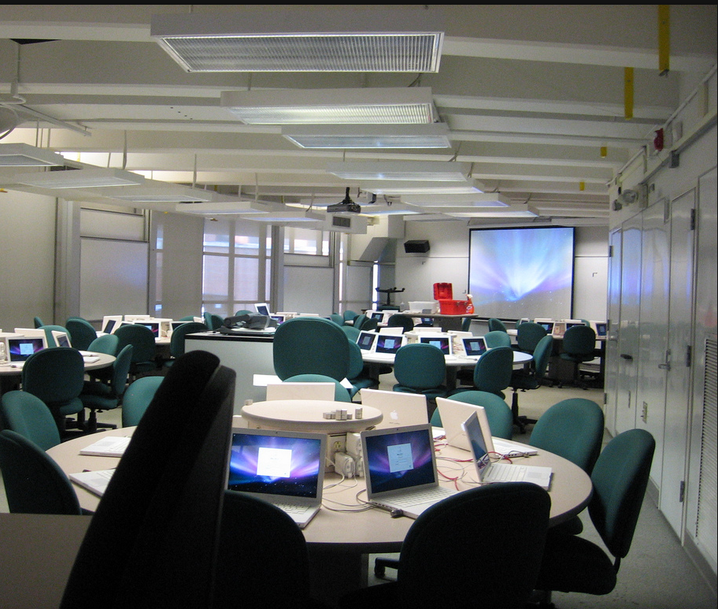

Figure 4. SCALE-UP classroom at NCSU, seating 99 students. Beichner suggests only one computer per team of three students. The room has one laptop per student since it is also used as a computer lab. Photo courtesy of Robert Beichner.

